* The default is 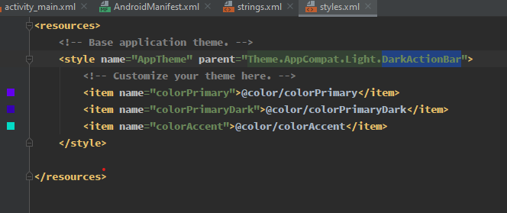

The DarkActionBar is responsible for this

